**Project Design Phase-II**

**Data Flow Diagram & User Stories**

| Date | 31 January 2025 |
| --- | --- |
| Team ID | LTVIP2025TMID59424 |
| Project Name | Citizen AI – Intelligent Citizen Engagement Platform |
| Maximum Marks | 4 Marks |

**Data Flow Diagrams:**

The Data Flow Diagram (DFD) for the Citizen AI platform illustrates how citizens interact with the system by submitting queries or feedback, which are then processed by the AI engine to generate real-time chatbot responses and sentiment analysis. The feedback data is stored in a centralized database, enabling government administrators to access meaningful insights via a dynamic dashboard. This flow ensures that citizen inputs are captured, analyzed, and visualized effectively, supporting improved governance, transparent communication, and data-driven decision-making.

**Example:** [**(Simplified)**](https://developer.ibm.com/patterns/visualize-unstructured-text/)

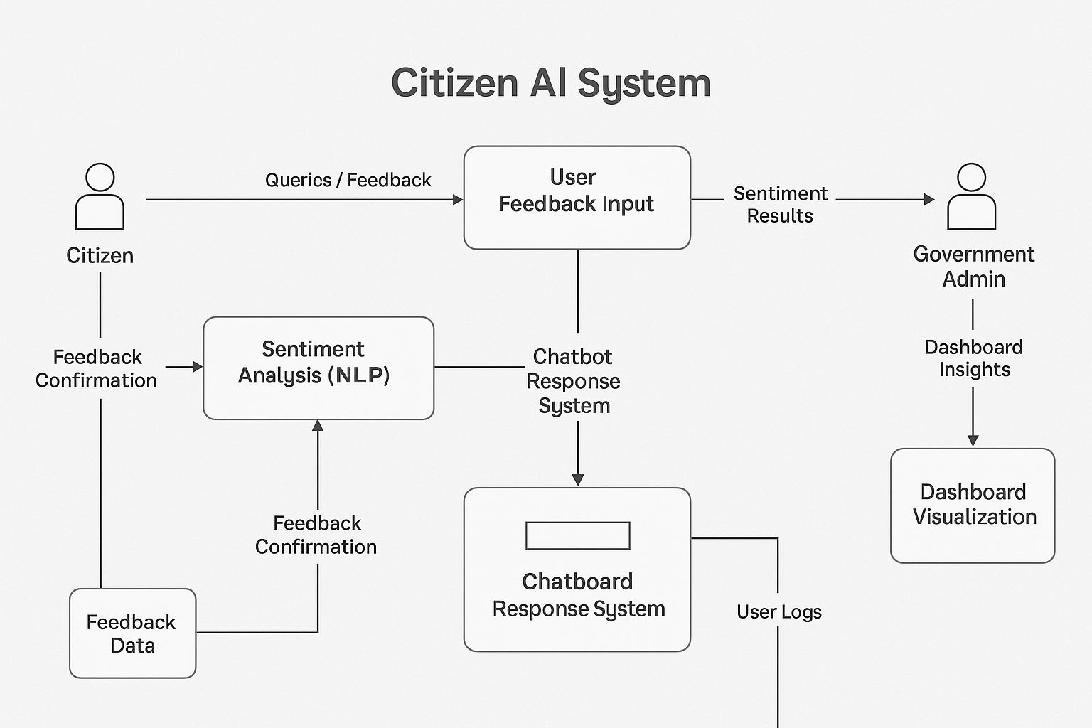

**User Stories**

Use the below template to list all the user stories for the product.

| **User Type** | **Functional Requirement (Epic)** | **User Story Number** | **User Story / Task** | **Acceptance criteria** | **Priority** | **Release** |
| --- | --- | --- | --- | --- | --- | --- |
| Customer (Mobile user) | Registration | USN-1 | As a user, I can register for the application by entering my email, password, and confirming my password. | I can access my account / dashboard | High | Sprint-1 |
|  |  | USN-2 | As a user, I will receive confirmation email once I have registered for the application | I can receive confirmation email & click confirm | High | Sprint-1 |
|  |  | USN-3 | As a user, I can register for the application through Facebook | I can register & access the dashboard with Facebook Login | Low | Sprint-2 |
|  |  | USN-4 | As a user, I can register for the application through Gmail |  | Medium | Sprint-1 |
|  | Login | USN-5 | As a user, I can log into the application by entering email & password |  | High | Sprint-1 |
|  | Dashboard |  |  |  |  |  |
| Customer (Web user) |  |  |  |  |  |  |
| Customer Care Executive |  |  |  |  |  |  |
| Administrator |  |  |  |  |  |  |
|  |  |  |  |  |  |  |
|  |  |  |  |  |  |  |
|  |  |  |  |  |  |  |